Role of Surface Protein in Conjugation:
Conjugation differs from transformation in the fact that in the former physical contact is established between two different strains through a conjugation tube. The genetic material from the donor cell (male) is transferred to the recipient (female) cell. There are special appendages present on bacterial cell surface which are called sex pilus or F pilus which forms the conjugation tube.
The fertility (F) factor enables the cell to act as donor. The F factor of donor cell includes the information’s of sex pili the number of which varies from 1 to 3. The cells containing an autonomous F are referred to as F⁺ cells. It replicates independently. There are only 1-3 copies of F factor per cell.
Under certain specific conditions the number of pili per cell goes to five. The number of pili corresponds to the number of copies of F factor. This explains that each F factor synthesizes a single pilus whether it is autonomous replicating conditions (as plasmid) or in integrated conditions (as episome).
Moreover, the recipient cells possess receptor sites on cell surfaces which are required for conjugation. Certain bacteriophages e.g. f₂, MS₂, and Qβ act as donor. The donor E. coli cells possess sex pili as well as type I pilus on their cell surfaces. For example phage M12 is adsorbed randomly only on sex pili but not on cell surfaces of recipient bacterial cell.

The F Factor:
The presence of F factor in a bacterial cell determines its autonomous replication, sex pili formation and conjugal transfer function. Thus, it governs the sexuality and conjugation.
Two mating types in E. coli K12 have been found to depend on presence and absence of the F factor. The F factor remains in two stages as plasmid and as episome. The F plasmid replicates independently. However, sometimes it is integrated with the normal chromosome of the bacterium. Therefore, it is referred to as episome.
The F factors have shown the following significant features:
(a) When F⁺ strain of a bacterium is incubated on a nutrient medium mixed with acridine orange, it is converted into F– strain. Acridine orange is effective only with the growing bacteria as it inhibits the autonomously replicating F factor.
(b) A cross between two F– strains does not yield recombinants. It is always sterile as the F– strain cannot undergo conjugation with the other F– strain.
(c) The crosses between F⁺ and F⁺ strain yield F⁺ cells but a very low level. Some of F⁺ cells are converted into F– genotype.
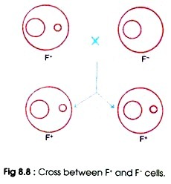
(d) Transfer of F factor from F⁺ to F– in F⁺ x F– crosses occurs at a frequency of about 100% but the production of recombinants occurs at the rate of one per 10⁴ to 10⁵ cells.
(e) Among F⁺ strains there are certain F⁺ sub-strains that show about 1000 time more rate of recombination with F– strains. The sub-strains are called high frequency recombination (Hfr) strains. The Hfr strains are produced when F factor integrates with the bacterial chromosomes.
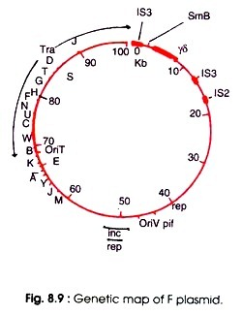

Genetic Map of F Plasmid:
A genetic map of F plasmid is shown in Fig. 8.9. The F plasmid of E. coli is about 100 kb with genes coding for autonomous replication, sex pili formation and conjugal transfer function. The F plasmid contains the transfer (tra) region and non-transfer related markers.
ADVERTISEMENTS:
The non-transfer related markers are the insertion sequences (IS3, δ, ү and IS2), stable DNA degradation (srn B), inhibition of replication by T7, and II phages (pif), and a region for replication (rep), incompatibility (inc) and origin of vegetative replication (oriV). Some genes of R plasmid with their functions are given in Table 8.1.
Willetts and Wilkins (1984) have given the physical and genetic map of transfer region of F plasmid (Fig. 8.10) which is about 32 kb long consisting of about 25 known transfer genes.
Twelve genes are involved in F pilus formation (e.g. tra A,-L,-E,-K,-B,-V,-W/C,-U,-F,-H,-G). Genes involved in regulation are finP and traJ. Stabilization of mating pairs is done by genes traN and traG, conjugative DNA metabolism by traM, traY, traD, tral and traZ and surface exclusion by traS and traT.
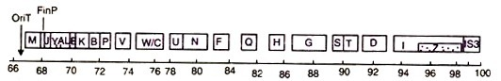
Fig. 8.10 : Physical and genetic map of the transfer (tra) region of F-plasmid.
The traM and traJ promoter regions have been sequenced and traY-Z operon possesses its own promoter. Transcription from the promoters for traM and traY-Z operon is dependent on the product or traJ which in turn is negatively regulated by the FinOP repressor. The tral and traZ genes are transcribed continuously from a second promoter at about 18% or the level from the tral induced traY-Z operon promoter.

